PRACTICAL-4

Implementation of word embedding techniques (Bag of Words and TF-IDF) in NLP using Python

- Bag of Words (BoW)
The Bag of Words model is one of the simplest and most widely used methods for converting text into numerical features for machine learning and NLP tasks.
The central idea is:
  - Treat every sentence or document as a “bag” of words.
  - Ignore grammar, sentence order, and structure.
  - Focus only on whether a word occurs in a sentence (binary presence) or how many times it occurs (frequency).

How it Works in the Code:

Preprocessing the Text
  - The input paragraph is split into sentences (sent_tokenize).
  - Each sentence is cleaned: converted to lowercase, punctuation removed, and extra spaces normalized.

Tokenization and Word Count
  - Sentences are split into words (word_tokenize).
  - A dictionary (word2count) is built that stores the frequency of each word.
  - Stopwords such as the, is, and are removed since they do not add much meaning.

Frequency Distribution and Visualization
  - Word frequencies are arranged in a pandas DataFrame.
  - The top 10 frequent words are shown using a bar graph.

Vector Representation (BoW Matrix)
  - For the most frequent words, a binary matrix is created:
    - Rows = Sentences
    - Columns = Words
    - Cell value = 1 if the word is present in the sentence, else 0.
  - This is displayed as a heatmap.

Why BoW is Useful:
- Simple, fast, and easy to implement.
- Provides a baseline representation for text classification and clustering.

Limitations:
- Ignores word order → “dog bites man” and “man bites dog” look identical.
- Produces very high-dimensional, sparse matrices for large vocabularies.
- All words are treated equally without considering their importance.

CODE:-
- Importing Libraries
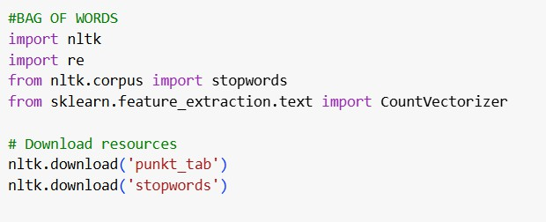
Output:
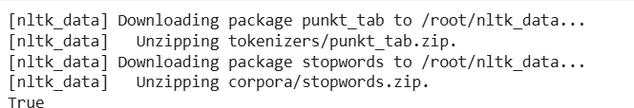

- Converting paragraph to sentences.

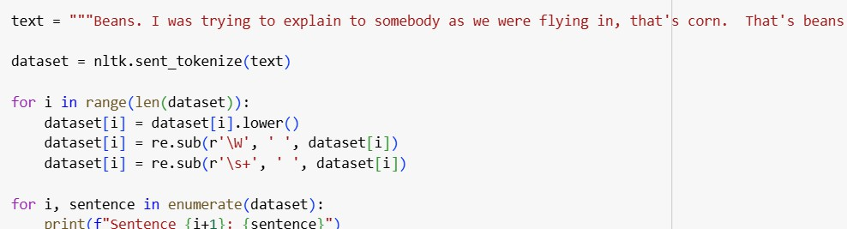
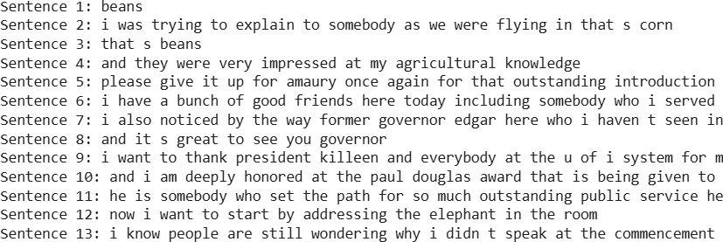

- Stop word removal and measuring frequencies

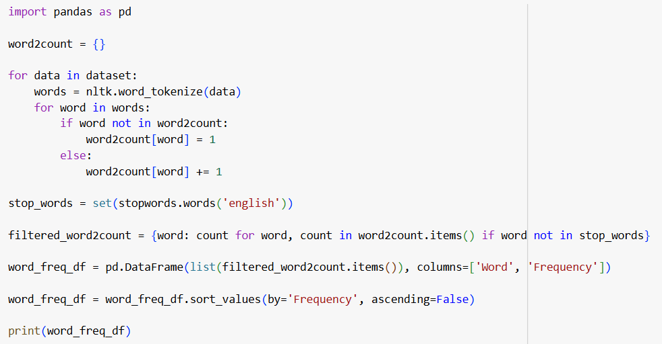

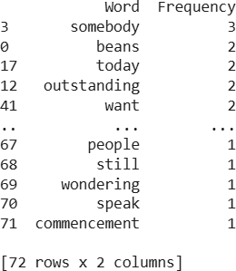
Output:

- Plotting the most frequent words.

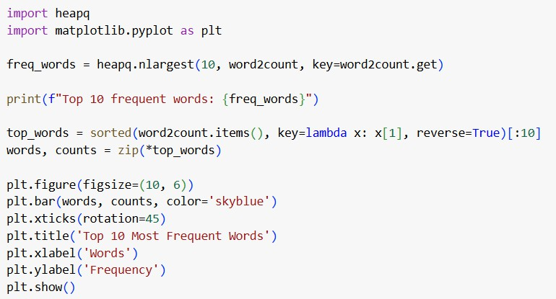

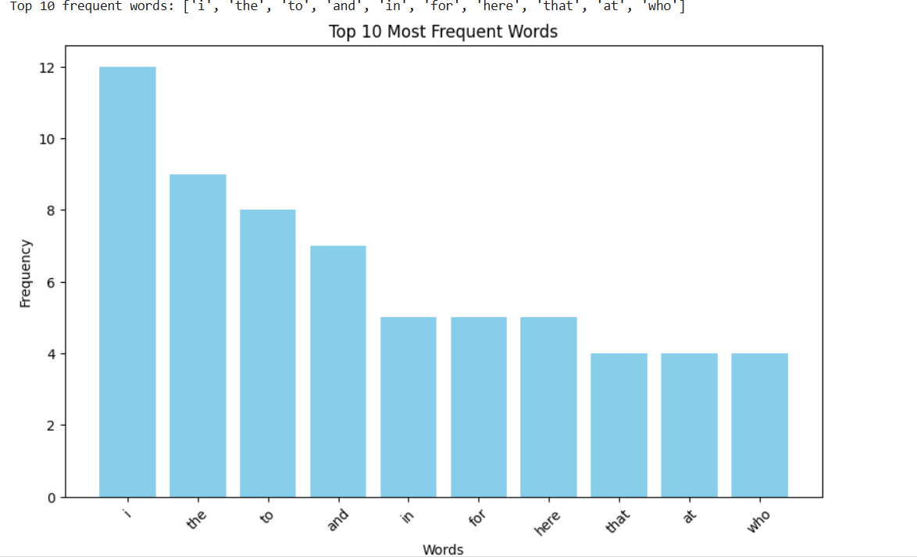
- Bag of word Matrix
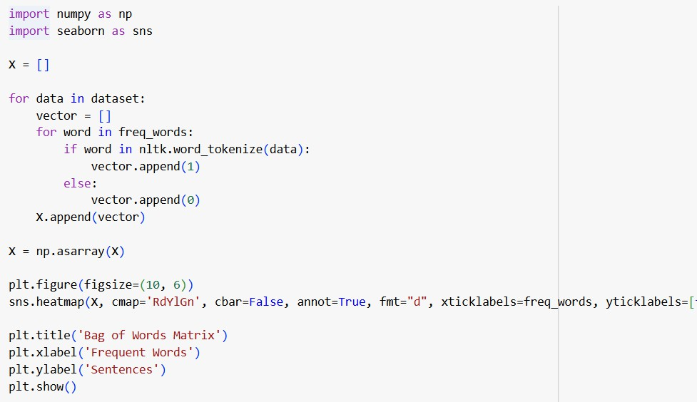

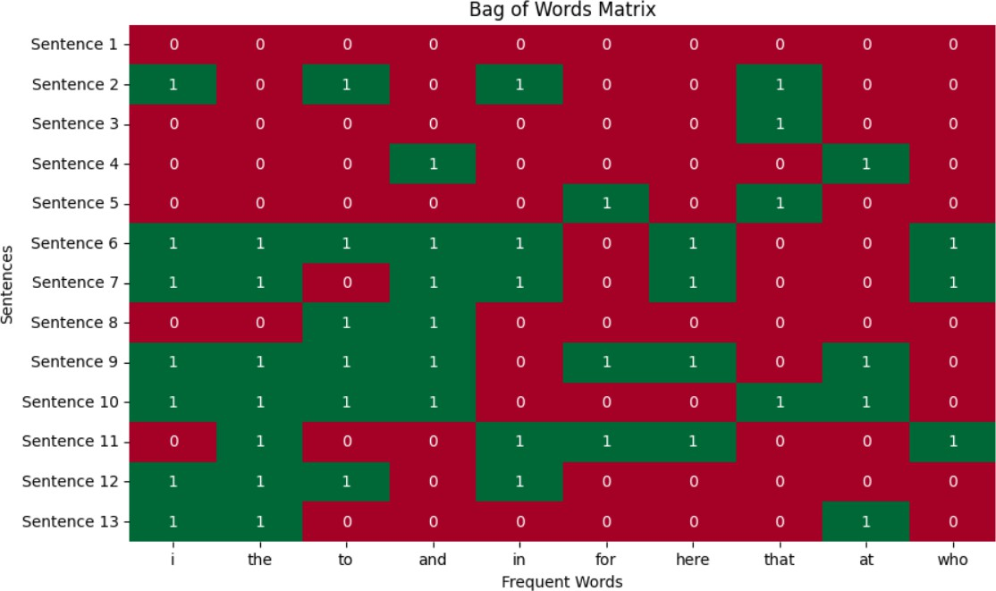

Term Frequency – Inverse Document Frequency (TF-IDF)
The TF-IDF model builds on BoW but adds a measure of importance for words. Instead of just counting, it evaluates how significant a word is to a particular document within a collection.

Key Concepts:

Term Frequency (TF):
Measures how frequently a word appears in a document.
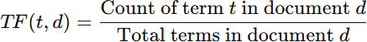

Inverse Document Frequency (IDF):
Reduces the weight of very common words that appear across many documents.

TF-IDF Score:
Combines the two:

This ensures:
  - Words frequent in one document but rare across others get high weight.
  - Common words (like “the”, “is”) get low weight.

Code:-
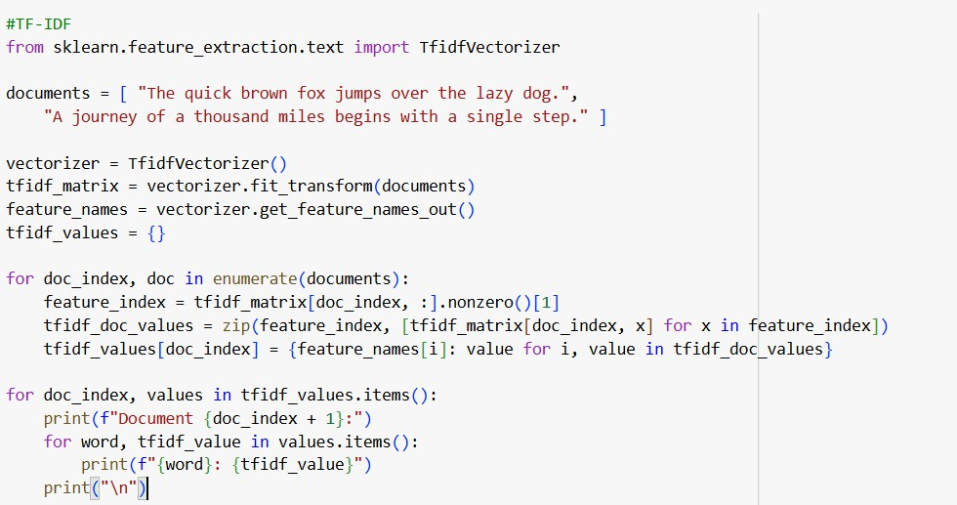

Output
